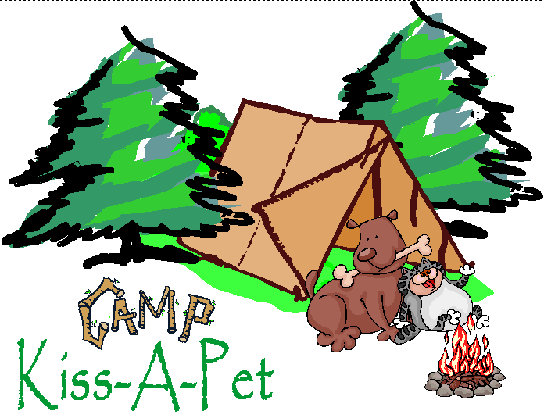
12251 NE Dudley Rd Newberg Oregon 97132 503-538-2354
CAMP AGREEMENT
- Services. We agree to provide the specific services (“Services”)to your Pet for each visit as indicated on the Service Card that will be filled out for each of your Pet’s visits. We will exercise reasonable judgment as we provide the Services.
- Payment for Services. You agree to pay “Camp Kiss-A-Pet” for the Services we provide to your Pet during each visit at the rates set forth at the start of such visit (collectively the “Charges”). Prices are subject to change without notice and seasonal rates may apply. Charges begin on the day you leave your Pet. A damage deposit of $100 is expected at time of check-in on your Pets Arrival Date. If your pet happens to damage or destroy CKAP property, the deposit will be used for repair or replacement costs. If no damages have occurred, the deposit will be applied to the invoice on date of checking out and the remainder of the balance will be paid at time of camper(s) discharge. Camp check-out time is by 11 am on the Departure Date and additional charges will be due for late check-out. Camp KAP is required to return your Pet to you at the time of check-out. You understand, however, that you will remain liable for all Charges incurred during your Pet’s stay, and Camp KAP reserves the right to collect any unpaid balance. Please note: credit card payments will have a convenience fee of 0.03% applied to the final total.
- Reservations. Reservations are accepted but not guaranteed without verification of Camp KAP requirements.
- Cancellations. If you need to cancel your reservation, please do so at least two (2) days prior to your arrival date. Camp KAP reserves the right to charge late cancellation fees.
- Your Custodian*. You must provide an adult, over the age of 18, as your Custodian. Your Custodian will be a person that has guardianship over your Pet while you are out of town. YourCustodian must also be someone other than the primary Pet Parent(s) and should not be someone travelling with you if you are leaving town. If we cannot reach you, you authorize us to contact yourCustodian. You understand that your Custodian can be contacted to resume responsibility if we unexpectantly run into issues in which we are unable to continue to provide care for your Pet or it becomes a risk to itself, our staff or any other camper.
- Emergencies. In an emergency or natural disaster, every effort will be made to contact you or your Custodian to retrieve your Pet. You agree that Camp KAP, at its sole discretion, is authorized to transport, and/or to make temporary alternative arrangements to house and care for your Pet until you or your Custodian or such other individual(s) designated by you in writing arrive to pick up your Pet.
- Check-In and Check-out. The office is open between the hours of 9-11am and 3-5pm, except on holidays, for check-in and check-out by appointment. It is preferred that designated times of check-in and check-out are scheduled as we put all other campers outside for ease of transition. CKAP employees may also be unavailable at the front desk if they are on nature hikes or involved in other activities. After hours check-in and check-out may be made in advance to accommodate your trip itinerary, however there is an after-hours fee of $10/hour. We may require government issued identification before releasing the camper(s) as we want to be sure we only release your Pet to you, your Custodian or such other individual(s) designated by you in writing as authorized to pick up your Pet.
- Pet Health and Behavior. We reserve the right to refuse to accept a Pet at check-infor any reason, including without limit, if it appears to us the pet is sick, injured, in pain, or that its behavior could jeopardize the health or safety of other Pets, itself, or our staff.
  - No Pet can stay with us unless the Pet is healthy and we have confirmation from your licensed veterinarian or approved designee that the Pet has received all vaccinations and parasite prevention required by Camp KAP. Our licensed veterinarian on staff is happy to update your Pet(s) preventatives at check in for an additional charge. If your Pet has never received vaccinations prior to the day of check-in, we are happy to vaccinate your Pet for the stay, but it may not be able to interact with the other animals for three days after vaccination to assure proper quarantine. This would require an additional special needs fee for those three days of specific care.
  - If at any time your Pet is found to have fleas, ticks, or internal parasites, we may provide the appropriate removal treatment, and you authorize us to provide such service at your additional expense.
  - We may accept certain older pets and provide basic testing and administer routine medicationfor chronic conditions, but we are not equipped to care for acutely sick Pets or aggressive or biting patients.
  - You represent that to the best of your knowledge, your Pet has not been exposed to rabies, distemper, parvovirus, leukemia, or FIP within 30 days prior to beginning its stay with us.
  - If your Pet has been treated for a contagious illness, we cannot accept your Pet for at least two (2) weeks after treatment has been completed and a statement of health is obtained from a licensed veterinarian or by examination from our resident veterinarian.
  - Communicable Diseases: all pets coming into the Camp and DDC are required to be vaccinated. However, it is still possible for a Pet to become ill, even if vaccinated. You understand this risk and agree that Camp KAP is not liable for any illness suffered by your Pet during or after its stay, including but not limited to Tracheobronchitis (Kennel Cough).
  - You acknowledge that we may contact appropriate authorities if your Pet bites another pet or any person.
  - You acknowledge and agree that in the unlikely event your Pet becomes ill or injured, or if your Pet has a pre-existing condition which is aggravated by its stay, and requires professional attention we will administer medication, attempt to treat your Pet, or give other necessary attention to your Pet, and you authorize us to provide any such services at your additional expense until we are able to notify your Custodian at the telephone numbers you provide on the Master Boarding Agreement. If we cannot reach you or your Custodian, Camp KAP at its sole discretion may engage the services of another veterinarian and/or make your Pet as comfortable as possible until picked up by you or your custodian. If we cannot reach you or your Custodian, we will make healthcare decisions for your Pet based on the judgment of our resident veterinarian.
- Pet Behavior and Contact with Other Pets. This facility offers free play and interaction within the premises and among other campers. While your Pet is staying with us, he or she could encounter an uncontrollable situation such as heavy play or personality conflicts that could lead to injury. Although every effort will be made to ensure the safety of our guests and staff by enforcing strict restrictions on Pets as set forth in Camp KAP’s policy and procedures, there is still potential for your pet to become ill or injured during their stay. We reserve the right to refuse to accept a Pet at check-in for any reason, including without limit, if it appears too aggressive, or that its behavior could jeopardize the health or safety of other Pets, itself, or our staff.
  - You acknowledge and agree that in the unlikely event your Pet is injured during its stay at Camp KAP, YOU RELEASE CAMP KAP AND ITS AGENTS FORM ANY LIABILITY FOR SUCH INJURY.
  - If your Pet injures another Pet you will be solely responsible for any injury to the other Pet(s) as well as your own Pet, and YOU RELEASE CAMP KAP AND ITS AGENTS FROM ANY LIABILITY FOR SUCH INJURY.
  - If your Pet is destructive and damages any of Camp KAP property, other than normally expected wear and tear, YOU WILL BE RESPONSIBLE FOR ALL CHARGES TO REPAIR AND REPLACE THOSE DAMAGED ITEMS.
  - If deemed necessary by Camp KAP management, you understand that your pet may be confined to its cabin and/or your custodian may be contacted to pick up your Pet before discharge date to eliminate any further behavioral issues.
- Pets not picked up on Departure Date. If you or your Custodian do not pick up your Pet at the agreed upon time, you hereby authorize us to continue to provide the Services as set forth in this Agreement at your expense. If Camp KAP determines, at its sole discretion, that an extension of Services is required, Payment in full may be required prior to extending such Services. Notwithstanding the foregoing, if your Pet is deemed abandoned under local, state, or federal laws or regulations, or in Camp KAP’s discretion as permitted by law, we will follow the Abandoned Pet Procedure.
- Abandoned Pet Procedure. Unless otherwise required by applicable law, if you fail to pick up your Pet by the designated time:
  - All Services will stop, with the exception of medication administration necessary to ensure Pet health and safety and basic boarding services (food, water, relief time and shelter). DDC guests may be converted to boarding services if the Pet has not been picked up within the lobby hours and you pay the expense;
  - We will attempt to contact you by telephone and/or in writing using the information that you have provided, advising you that if your Pet is not picked up within a reasonable time period, your Pet will be deemed to be abandoned and that we will deliver the Pet to a third party adoption partner, animal Control or other similar government agency. You understand that you may lose ownership of your Pet under these circumstances. If you fail to pick-up your Pet for any reason, YOU RELEASE CAMP KAP FROM ALL FURTHER LIABILITY AND RESPONSIBILITY FOR YOUR PET.
  - You shall remain liable to us for all unpaid Charges, including without limit the court costs and reasonable attorneys’ fees incurred in the collection of the Charges.
- Your representations to us. You represent to us that you are the owner of the Pet and that you are fully authorized to enter into this Agreement. All of the information about you and your Pet in this Agreement is true, accurate and complete. In a custody dispute, we will exercise reasonable judgment based on the known facts and we may, in our sole discretion, require proof of ownership, a written property settlement agreement or court decree.
  - To the best of your knowledge, your Pet has no illness, injury or behavior problem (including aggressive or biting behavior) that has not been disclosed to us.
  - You agree to indemnify and hold us harmless, from and against all loss, damage or expense including attorney’s fees, resulting from misrepresentations by you or your representatives resulting from your Pet’s stay including, without limitation, any person claiming to be the owner of your Pet and any person claiming damage or injury by your Pet.
- Miscellaneous Provisions. This written Agreement constitutes our entire and only agreement and there are no oral agreements or understandings except as provided for in this Agreement.
  - This Agreement shall bind us and our assigns and you and your heirs and assigns.
  - The law that applies to the agreement is the law of the state of province and municipality where your Pet is to stay. If there are disputes that result in litigation, the courts of the state or province and municipality where your Pet is to stay shall have exclusive jurisdiction.
- Personal items.Do not bring items with your Pet that are valuable or irreplaceable. Camp KAP is not responsible for loss or damage to any personal item or toys left with your Pet.
- Definitions. The terms used throughout this Agreement, whether capitalized or not, and in either the singular or plural form, shall mean as follow: “We”, “us,” “DDC,” “Camp” and “Camp KAP” means Camp Kiss-A-Pet. “YOU” and “YOUR” shall mean the Pet Parent(s) signing this Agreement. “Pet” and “Camper” shall mean the dog(s) and cat(s) staying at Camp Kiss-A-Pet and “your Pet” shall refer to the Pet(s) designated by the Pet Parent in this Agreement.

WE LOVE TO TAKE PICTURES OF OUR CAMPERS AND POST THEM ON OUR WEB PAGE, FACEBOOK, YELP AND OTHER PUBLIC DOMAINS!!
If you are NOT willing to allow your pets photos to be posted publically, please check the box. NO

Pet Parent Signature____________________________________________Date________________
Pet____________________________ Current Visit Date_________Initial_____________
Pet____________________________ Current Visit Date_________Initial_____________
Pet____________________________ Current Visit Date_________Initial_____________
Pet____________________________ Current Visit Date_________Initial_____________
Pet____________________________ Current Visit Date_________Initial_____________

